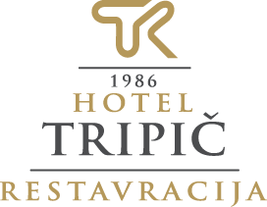

10% popust na kosilo ali večerjo.
Popust velja le ob plačilu z gotovino in ob obveznem predhodnem opozorilu
strežnega osebja.
10% discount for lunch or dinner.
Discount is valid only with cash payment and
it is obligatory to inform waiters before asking for the check.

Kuhinja / Kitchen: 10.00 – 21.30

10% popust na kosilo ali večerjo.
Popust velja le ob plačilu z gotovino in ob obveznem predhodnem opozorilu
strežnega osebja.
10% discount for lunch or dinner.
Discount is valid only with cash payment and
it is obligatory to inform waiters before asking for the check.

Kuhinja / Kitchen: 10.00 – 21.30

10% popust na kosilo ali večerjo.
Popust velja le ob plačilu z gotovino in ob obveznem
predhodnem opozorilu strežnega osebja.
10% discount for lunch or dinner.
Discount is valid only with cash payment and
it is obligatory to inform waiters before asking for the check.

Kuhinja / Kitchen: 10.00 – 21.30

